Volume 15, Number 10 October 2010

The Nugget

The Newsletter of the Mother Lode DX/Contest Club.

MEETING DATE, LOCATION & PROGRAM
When: Our next meeting is Saturday, November 13th at 12:00 noon.
Where: Mountain Mike's Pizza in Martel, CA. They are located in the shopping center with Save-Mart on Highway 88, just west of Highway 49. Our meeting room is reserved from 11AM-3PM. At our regular time (noon) (The room is reserved from 11AM-3PM.) See the club’s website at http://www.mldxcc.org/ and click on “meetings” for a map and more information.
What: The program is TBD.

Below is a photo of some of us at the October 2010 meeting in Martel.
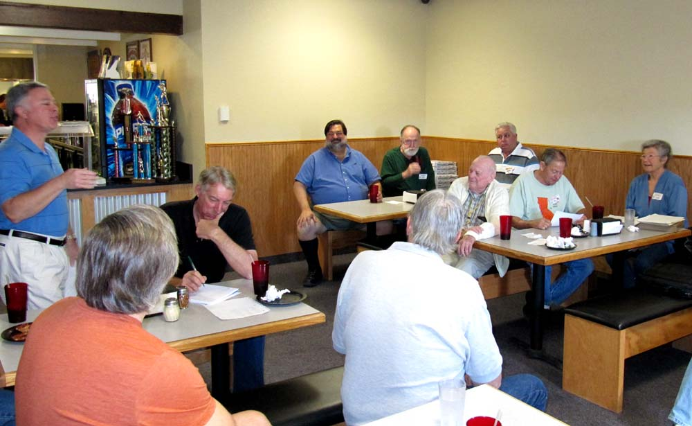

From the Prez:
I would like to thank all of our members who went that extra mile to help the MLDXCC to another CQP victory (we hope) and congratulate all the other clubs that participated in the contest. With all the competition, it made the CQP a bigger success for all the participants. I was reading the comments on 3830 from the out of state stations they seemed to really enjoy our QSO party.
Many thanks to Rick N6RNO, the NCCC and all the others’ who help make this the best QSO party in the nation.
Now with one contest behind us, our attention is on the CQ WW DX Phone contest which is the last full weekend in October. Followed immediately by the SS CW contest the first weekend in November, looks like contest season is upon us. During the SS contest we should be listening for the local hams that give us a call, we need to write their call sign down, and after the contest contact them and invite them to our club meeting. The local people that we work are the ones most likely to have an interest in contesting, or we would not have worked them, right? Now is the time to add to our club roster for next year’s Cal QSO Party competition. Let’s finish this year strong with lots of new recruits and great contest scores.
73, Rich, WC6H

VP’s QRM
The November meeting of the Mother Lode DX / Contest Club will be at Mountain Mike's Pizza in Martell on November 13th at 11:30AM. Mountain Mike's is located in the Amador Plaza shopping center with SaveMart on Highway 88, just west of Highway 49. The program is presently TBD but if we do not get a presentation we will have a video.

I would like to give a hardy “thank you” to all who participated in the CQP. Our club amassed over 3 million points and it appears that we have successfully defended our title.

On Contest subject I would like to encourage all members to participate in events which our membership designated as targeted events. These events are listed in red on the Contest Calendar section of the club’s web site. Our next club event is the CQWW DX Contest. The Phone event is on 30-31 October and the CW event is on 27-28 November.

An important reminder: For proper club credit in CW and ARRL sponsored contests your log must precisely identify your club as Mother Lode DX/Contest Club otherwise it will not be accepted as an entry for our club.

A reminder that we continue to need topics and presenters for our club meetings so if you have something please let us know.

73 de AA6K
Shirley

Tube of the Month de Norm, N6JV

TRIGATRON

One of the common uses for vacuum tubes is as a switch. Some common types have been modified to switch at high speeds as was needed in early vacuum tube computers. RADAR is still a user of high power vacuum and gas tubes for switching voltage to magnetrons. One odd tube developed and still used by the British for switching, is the trigatron. The RAF had problems with their RADARs at high altitudes. What they came up with isn’t actually a vacuum tube. It would be more correct to call it a pressure vessel. After many experiments, a mixture of 93% argon and 7% oxygen was pumped into the envelope at a pressure of about 65 PSI. Two of the three electrodes within the envelope would conduct when the trigger electrode was pulsed. This example of the CV100 we have shown here would control up to 250 KW at a voltage of 24 KV.

Vacuum tubes are like light bulbs and when dropped, they break with a pop as the tube implodes. Not very dangerous. The trigatron is another problem. When it breaks, it explodes. To protect the operator from flying glass, they made a machine similar to what they use to make socks for people. The thread seems to be nylon line and a coating of lacquer. Very nice stitch work.

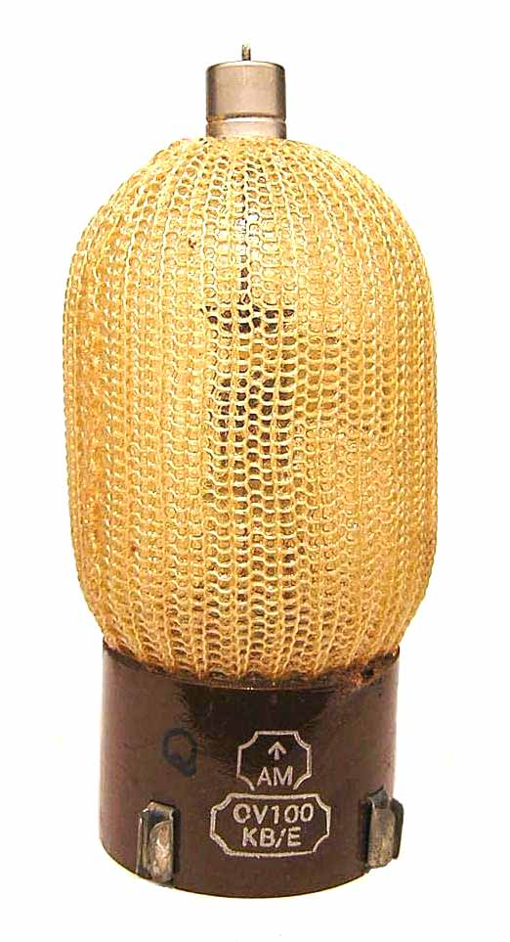

Member news/feedback/Announcements.

Martin and I beat our 2009 CQP score by over 40K points. At W6SR's suggestion, I built a 80 meter sloper on the east facing slope of my hillside. The results on 80 meters were best expressed by this comment on a packet spot, from WX3B, during CQP: SMASHING signal
I also put up a 40 meter sloper with a passive reflector about 20 below it. It also worked well and the combination of the two slopers definitely helped our score this year.
Now, I need a 40 meter beam, a preamp for the Beverage, and I need to find the source of the high noise level I have on the big beam on 15 and 20 meters. Also need to get towers 2 and 3 up before CQP next year.
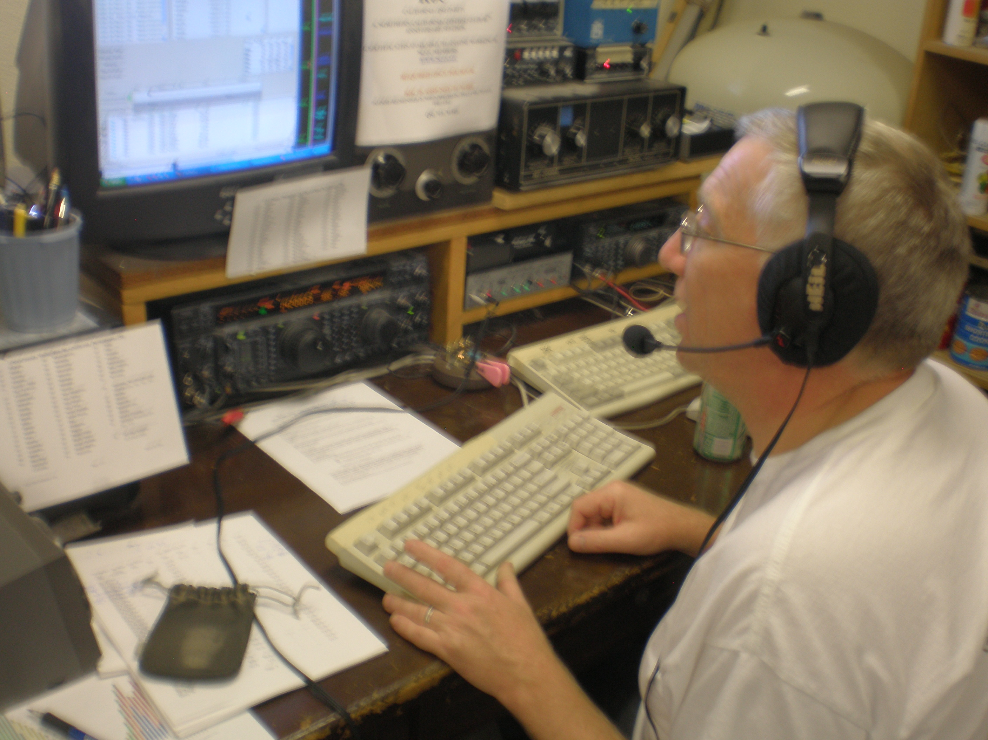

Above is a picture of Martin, AA1ON, operating K6C M/S with W1RH from W1RH QTH.
=========================================

Hi Gang,
Here is an after action photo from CQP.
Try to call CQ during the contest and have power line noise. After the contest, cursed PG&E for a thousand generations for not repairing said power line. 10 days later, have this sign placed just before my driveway and watch 8 or 9 line trucks show up to rebuild the line. VooDoo works!
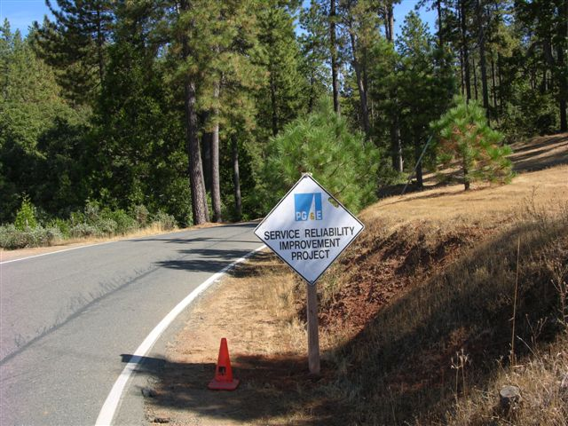

Below is a photo of the 60 KV line from the West Point hydro plant to
Valley Springs(It’s probably is used to supply power to the WC6H super station!).
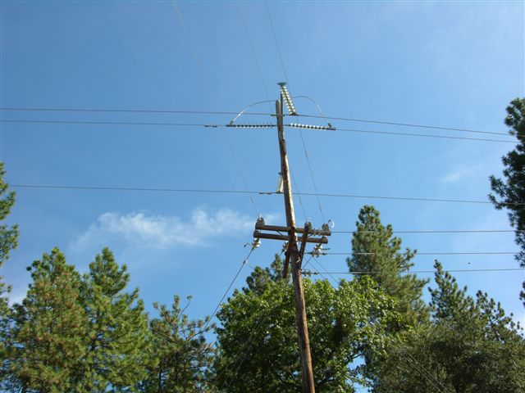

73, Rick, W6RKC
==========================================

Below are some pictures taken by N6JV at our September meeting.

Rick, N6RNO explaining some of the fine point of CQP to our membership.
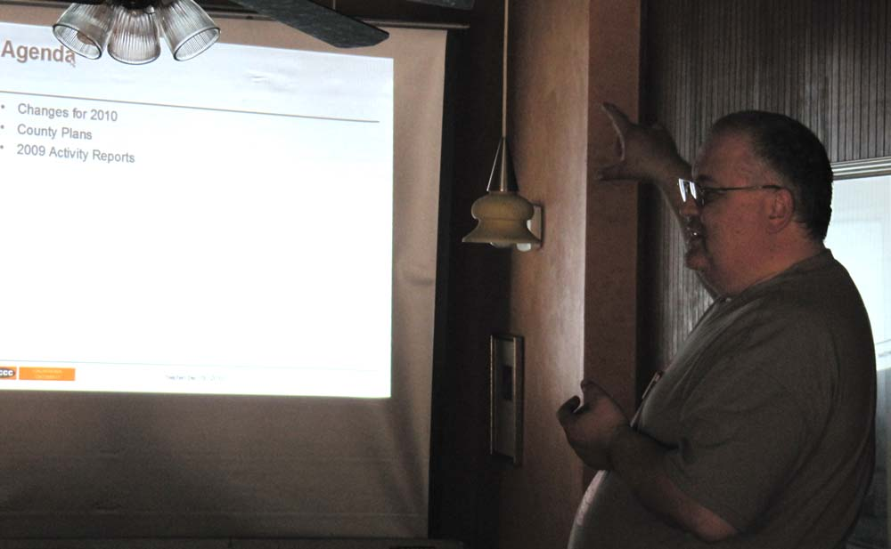

A shot of the most popular place, the dinning table.
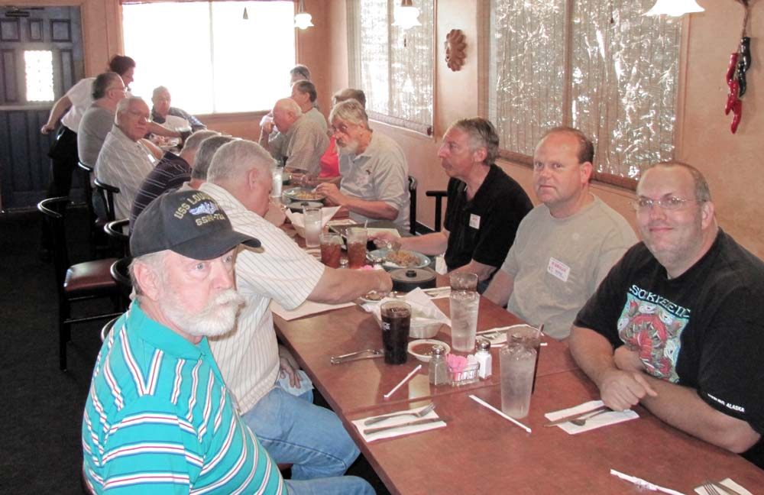

Glen, WR6O, giving a presentation on the winter Olympics.

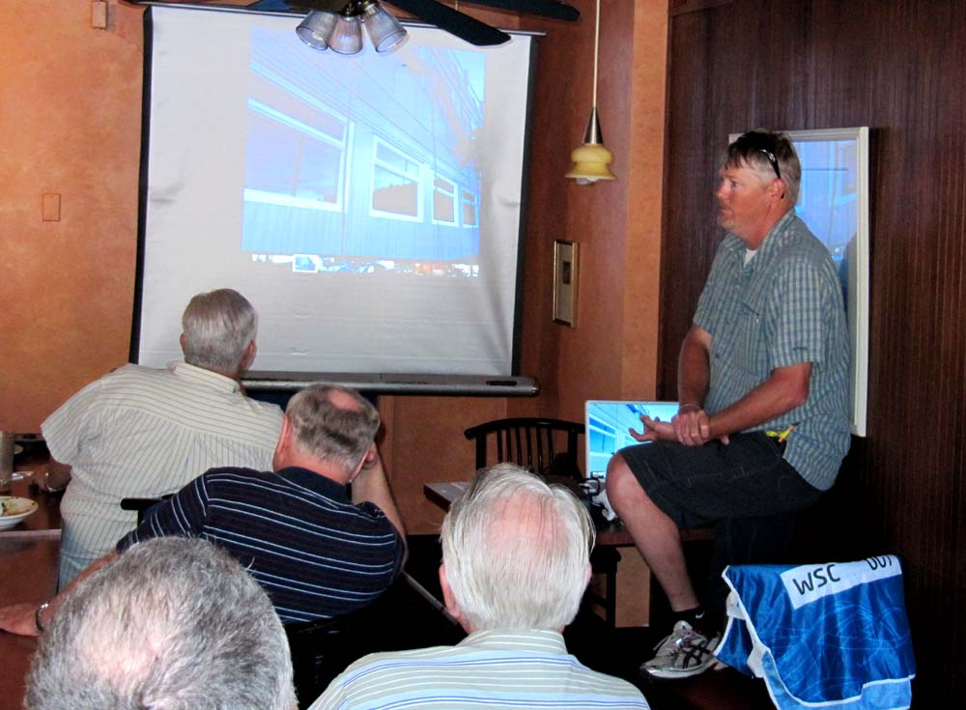

Editor’s Notes de Rick, W6SR
Hi All
Karen and I have been into more Corvette events the past month than ham radio stuff. But that all changed on 10 October with the addition of the four new PJ entities. So far I have worked all of em’ on phone and CW as well as on 15, 20, 40, and 80. I need eight more band countries (of the 36 band countries) to close em’ out on all nine bands. All completed with less than 8 hours total effort, so far.
I have been planning some antenna work for a while now and have corralled N6JV and K6STS, now all I have to do is arrange a mutual time for all of us, man being retired sure limits your available time, HI HI Enough for now, see ya’ all at the next meeting.…….de Rick, W6SR

October 2010 Treasurer’s Report

Balance September 1, 2010: $1850.09

Income: Dues – AE6Y 15.00

Expenses: Badge overcharge
Refund 1.00
Speaker’s lunches
W6RO, N6RNO 29.36
30.36

Balance September 31, 2010: $1834.73

Carolyn Wilson, K6TKD
Treasurer

MOTHER LOAD DX / CONTEST CLUB
GENERAL MEETING
September 18, 2010

Call to order
President Rich Cutler, WC6H, called the meeting to order at 12:15 PM. The meeting was held at Colima De Oro, in Shingle Springs.

introductions
The president called for introductions. 15 were present at the meeting.

Old Business

October Meeting
To be held in Martel.

NEW BUSINESS

CQP

Some discussion about REDXA being a serious competitor this year. We need out members active and willing to spend extra hours in the chair.

Per President Rich, the goal is to double last year’s score.

Rick, N6RNO, when commenting about the club competition, said that CQP follows the ARRL rules regarding member’s scores submitted to CQP on behalf of the club. If scores are close in the club competition, membership rosters will be requested by the CQP contest committee.

Wine Prize

Dana, N6DW, offered to donate two bottles of wine to be used as prizes for the highest low power and high power MLDXCC member scores in the 2010 CQP.

W1RH suggested a special, one page newsletter be sent out just prior to CQP reminding members to be active in the contest.

It was noted that roster members need to be notified that their scores will be claimed for MLDXCC unless the member requests the scores be submitted on behalf of another club.

Dues

A motion was moved and seconded to enact a one year moratorium on membership dues for existing members. All members currently on the roster will be considered paid up through 2011.

Future Meeting Ideas

N6JV suggested an old timers meeting. Members bring pictures and equipment from their early days in ham radio.

MEETING CLOSED

The Meeting was closed at 12:44 PM

PRESENTATION

Glenn Stilwell gave an entertaining talk about his work in the broadcast of the Vancouver Winter Olympics.

Attendance

NAME | CALL | QTH | MLDXCC | NCCC
Rick | N6RNO | Sunnyvale |  | X
Dick | K6LRN | Omo Ranch | X | X
Dana | N6DW | Granite Bay | X | X
Carolyn | K6TKD | Omo Ranch | X | X
Norm | W6JV | Sacramento | X | X
Ken | K6TA | Pine Grove | X | X
Kay | K6KO | Pine Grove | X | X
Jettie | W6RFF | Roseville | X | X
Shirley | AA6K | Stockton | X | X
Rich | WC6H | Valley Springs | X | X
George | KJ6OJV | Valley Springs | X
Bob | W1RH | Lotus | X | X
Brandt | K6BEW | Jackson | X | X
Ed | KG6PRX | Mountain House
Glenn | WR6O | Rancho Cordova

de Bob, W1RH

Click on the Hyperlink below to check-out the MLDXCC scores in the latest contests.
http://mldxcc.org/scores.html

UP-COMING DX and Dxpeditions
Click the link below to display up-coming Announced DXpeditions:
http://www.ng3k.com/Misc/adxo.html

OPDX Bulletin 980 October 11, 2010
The Ohio/Penn Dx PacketCluster
DX Bulletin No. 980
BID: $OPDX.980
October 11, 2010
Editor Tedd Mirgliotta, KB8NW
Provided by BARF80.ORG (Cleveland, Ohio)
2M, SCOTLAND (Satellite Op)
Paul, 2E1EUB, will once again be active as 2M1EUB between October 9-23rd. He will be active on all the satellites from northeast Scotland in the Cairngorms National Park. Also, look for him on 160 and 80 meters. During the the last 7 days, Paul will be active from the northwest coast, activating a new Grid Square. Checkout (QRZ.com) under 2M1EUB for more info.
2U1/GU3/MU3, GUERNSEY
Operators Dave/G1OCN (GU1OCN), David/M3IOP (MU3IOP) and Carol/2E1DQZ (2U1DQZ) will be active from the Island of Alderney (EU-114) between October 29th and November 5th. QSL via G1OCN.
4L, GEORGIA
Operator Andi, UU0JM, will be active as 4L0A from Obcha during the CQWW DX SSB Contest (October 30-31st) a Single-Op/All-Band/ High-Power entry. QSL via LoTW.
5Z4, KENYA
Sam, G4OHX, is currently active as 5Z4/G4OHX near Mombasa. His length of stay is not known. Activity has been mainly CW on 20 and 17 meters. QSL via his home callsign.
9M2, WESTERN MALAYSIA
Operator Rich, G4ZFE, will be active as 9M2CNC from Kuala Lumpur during the CQWW DX CW Contest (November 27-28th) as a Single-Op/Single-Band (20m) entry. QSL via G4ZFE, by the Bureau or direct. All QSOs will be confirmed via eQSL and LoTW.
9Q50, DEM. REPUBLIC OF CONGO
Patrick/ON4HIL will once again return but with Theo/ON4ATW, Marc/ON6CC, Luc/ON4IA, Wim/ON4CIT and Ron/PA3EWP and activate 9Q50ON from Kinshasa between December 3-13th. The special event callsign is to celebrate the 50th anniversary of the independence of the Democratic Republic of Congo. Activity will be on 160-6 meters using CW and SSB. QSL via ON4BR, by the Bureau or direct. For more details, updates and suggested frequencies, visit:
http://www.9q50on.be
AT10, ANTARCTICA
Time is running out to work Bhagwati, VU3BPZ, the communications manager of the 29th Indian Expedition at the Antarctic Maitri Base station, as AT10BP. Bhagwati and his team have less than 2 months remaining at Maitri. Activity by AT10BP is SSB only usually on the air around 1700z between 14276-14280 kHz. QSL direct only via I1HYW. For more info, visit the Worldwide Antarctic Program (WAP) Web page at:
http://www.waponline.it
Also, Michel/F6DWQ and Mehdi/F5PFP have put together a nice slideshow with music depicting the Maitri Base station at:
http://www.french-polar-team.fr/VU_Maitri_Station_Antarctica.php
CE4, CHILE
Operators Pedro/CE3FZ, Roberto/CE4CT, Fabian/LU1AEE, Ramon/ XE1KK and Diego/LU8ADX will be active as CE4CT during the CQWW DX SSB Contest (October 30-31st) as a Multi-2 entry. QSL via EA5KB. Look for operations before and after the contest between October 29th and November 3rd by operators CE3/LU1AEE, CE3/LU8ADX and CE3/XE1KK. QSL via their home callsigns (QRZ.com).
CE0Y, EASTER ISLAND
Operators Rolf/DK2ZF and Martin/DK7ZB are now active as CE0Y/DK2ZF and CE0Y/DK7ZB from Easter Island (SA-001) until October 23rd. They plan to focus on the 50 MHz, 144 MHz and 432 MHz EME, but also look for them on 30/20/17/15 meters using CW and SSB. QSL via their home callsigns. After they are done on Easter Island, they will move to main- land Chile and be active as as CE2/DK2ZF and CE2/DK7ZB.
CX, URUGUAY
Dale, N3BNA, will be active again as CX/N3BNA between October 22nd and November 13th. He plans to be active on 60 meters this trip using a sloping dipole off a tall tower. He may also try a half-square wave antenna for more gain. QSL via KA2AEV.
FSDXA ANNOUNCES THEIR PLANS FOR 2011 (Update)
Members of the Five Star DXers Association (FSDXA) finally announced their plans for 2011 at the RSGB Convention this past week. The FSDXA will be heading to the Pacific Ocean like they mentioned earlier. Their plans are to activate Christmas Island (T32) using 24 (or more) operators, with 15 FT-5000s and 15 VL-1000 amps. More details are forthcoming. Remember, this is the same group who is well known for their great operations to: Comoros (D68C), St. Brandon Island (3B7C), Rodriguez Island (3B9C) and Spratley Islands (9M0C).
H40, TEMOTU PROVINCE (H40KJ and H40BQ Op Cancelled!)
Jacek, SP5DRH, informs OPDX readers: "I regret to inform the DX Community about the cancellation of our Temotu DX-pedition. The cancellation is the effect of a dramatic plane delay that caused total destruction of our trip planner. We have lost all our booked and already paid connections to Solomon and Pigeon Island. Carrier has not been able to establish new and suitable for us booking to continue our trip. What we have been offered was far beyond the time we could spend on this dx-pedition. Therefore, we have decided to go back to Warsaw.
Under these circumstances, we feel obliged to refund the donations that we received, however, as we have suffered substantial financial loss, we suggest to transfer these funds for the expedition to come - Kiribati T30RH/T30AQ. Should any of donators disagree with our suggestion, please email us, and we will try to refund his donation as soon as possible." For more details, see:
http://www.sp5drh.com/h40
H40, TEMOTU PROVINCE
German operators Peter/DG1FK and Sigi/DK9FN will once again return to Temotu Province and be active as H40FK and H40FN, respectively, this time from Nendo Island (OC-100) between December 21st and January 3rd (2011). Activity will be on CW, PSK and RTTY. Operations will probably be on 160-6 meters depending on the band conditions. QSL H40FN via HA8FW, and H40FK via DG1FK. More details should be forthcoming.
HQ2, HONDURAS
Dan, HR2DMR, will be active as HQ2W during the CQWW DX SSB Contest (October 30-31st) as a Single-Op/All-Band/High-Power entry. He will be using monobanders and a new 40 meters 2 element beam. He will also be in the CQWW DX CW Contest (November 27-28th) as a Single- Op/All-Band/Low-Power entry. QSL both contests via HR2DMR (QRZ.com) or LoTW.
IOTA NEWS
AS-015. Richard, PA0RRS, is now active as 9M2MRS from Penang Island until April 2011. Activity has been on 20 and 17 meters CW. QSL via: Richard Smeets, Constance Gerlingsstraat 60, 5121 ZR Rijen, The Netherlands.
AS-154. Operators Pavel/OK1MU/TA2ZAF, Honza/OK2ZAW and Dan/OK1HRA will be active using the special callsign TC03W from the Turkish Island of Giresun in the Black Sea, between October 15-18th. Activity will be mainly on 30 and 20 meters using CW and SSB. QSL via OK2GZ, by the Bureau or direct. For more info, updates, photos and an online log, visit the following Web page at:
http://www.okdxf.eu/expedice/en/tc03w/www
EU-012. Chris, GM3WOJ/ZL1CT, will be active as GZ7V from Shetland Island during the CQWW DX CW Contest (November 27-28th) as a Single-Op/All-Band/High-Power entry. QSL via N3SL. For updates, check the Web page at:
http://www.gm7v.com
EU-125. Michael, DL4ABO, is active as OZ/DL4ABO from Romo Island (DIA NS-001) between now and October 16th. Activity will be holiday style mostly on 40 and 30 meters CW only, using a TS-570 w/100 watts into a ground-plane antenna. QSL via his home callsign, direct or by the Bureau.
EU-171. Mic, DG5LAC, is active as OZ/DG5LAC from Vendsyssel-Thy (DIA NJ-001, WW Loc. JO47GA) between now and October 15th. Activity will be holiday style on 80-10 meters SSB using FT-450AT, an Ameritron AL-811H amp and a DX-Wire Windom 42m antenna. QSL via his home callsign, the Bureau is preferred. Logs will be uploaded to LoTW and eQSL.
NA-091. Rob, VE7RSV, will be active as homecall/p from Broughton Island (CISA BC026) during the W/VE Islands Contest (October 23-24th). Activity will be on all bands, SSB only. QSL direct to VE7RSV (QRZ.com).
OC-066. Hiro, JI1JKW, will again return to French Polynesia, but this time to activate Tikehau Atoll (OC-066), Tuamotu Archipelago, as FO/JI1JKW between October 10-14th. Activity will be on 40-6 meters ( mostly 20m) using CW and SSB. QSL via his home callsign.
OC-172. (Update) Just a reminder that Craig, VK4LDX, will be active as VK4LDX/P from Fitzroy Island between October 16-22nd. This IOTA hasn't been on the air since 2003. He will be on the island with his wife, so his activity will be holiday style. Craig will be running 100 watts into verticals and/or dipoles for 40/20/15 meters, using SSB, PSK31 and RTTY. He will have a beach side cabin and will be setting up the antennas right on the beach. Craig mentions that "considering the high level of activity with PJ DXpeditions" during his stay on OC-172, he has announced his operating schedule (on his Blog page) to avoid as much pile-up QRM as possible and give people the chance to work this IOTA. QSL info is available on (QRZ.com), visit the following Blog page for more details and updates at:
http://vk4ldxoc172.blogspot.com
KH2, GUAM (Update)
Operators Kiyoshi/JA7RPC and Mitsuru/JH7DFZ will be active as KH2/JA7RPC and KH2/JH7DFZ between November 5-7th. Activity will be on 80-10 meters using CW and SSB. QSL OK via Bureau or direct.
KH6BZF PROPAGATION FORECAST/REPORT (For October 11-17th)

Oct 11 HN SOLAR REFERENCE KEYS
Oct 12 HN --------------------
Oct 13 HN BN - Below Normal
Oct 14 HN AN - Above Normal/Geomagnetic Level is QUIET
Oct 15 AN LN - Low Normal
Oct 16 AN HN - High Normal/Geomagnetic Level is UNSETTLED
Oct 17 AN DIS - Disturbed
VDIS - Very Disturbed

GEOMAGNETIC REFERENCE
---------------------
QUIET - The "A" index is expected to be between
0-7 and the "K" index will be 2 or less
UNSETTLED - The "A" index is expected to be between
7-16 and "K" index will be 3 or less
SPECIAL NOTE (Updated) FROM LEE, KH6BZF: On "Radio Havana", there is an interesting DX and propagation program, hosted by Senor Arie Coro Antich, CO2KK, every Monday at:
0600 kHz EASTERN North AMERICA from 0100-0500z
9820 kHz CENTRAL North AMERICA from 0100-0700z
9550 kHz WESTERN North AMERICA from 0500-0700z
KP4, PUERTO RICO
Operators James/KH2RU, Rene/NP3O and Javier/NP4JA will be active as KP4/KH2RU during the CQWW DX SSB Contest (October 30-31st) as a Multi-? entry. QSL via NP3O.
OH0, ALAND ISLAND
Look for OH0Z to be active once again in the CQWW DX SSB Contest (October 30-31st), but as a Single-Op/All-Band/High-Power entry. Operator will be Tomi/OH6EI. QSL via W0MM.
PJ STATIONS LIST (UPDATED) EXPECTED TO BE ON THE AIR NOW AND IN THE COMING WEEKS:

PJ2T - Curacao Island; October 10th-November 2nd; QSL via N9AG or LoTW.
PJ2/OH1VR - Curacao Island; now through October 13th; QSL via his home callsign.
PJ4B - Bonaire Island; October 10-22nd; QSL via PA8A.
PJ4D - Bonaire Island; October 10-22nd; QSL via W3HNK.
PJ4I - Bonaire Island; October 10-22nd; QSL via DL9USA (this may change).
PJ4N - Bonaire Island; October 10-22nd; QSL via W3HNK.
PJ4W - Bonaire Island; October 10-22nd; QSL via W3HNK
PJ4/W9NJY - Bonaire Island; October 16-29th; QSL via W9NJY or LoTw after the January 1st (2011).
PJ5/K1XM - St. Eustatius; now through October 17th; QSL via KQ1F.
PJ5/AH6DX - St. Eustatius; now through October 15th; QSL via AH6DX, direct or by the Bureau.
PJ5/AA4NC - St. Eustatius; October 9-15th; QSL via AA4NC direct only. Logs will be uploaded to LoTW. NO BUREAU QSLs.
PJ6A - Saba Island; October 10-22nd; QSL direct only to N4NX, or use the online OQRS system for direct and Bureau QSLing.
PJ6/K4LMY - Saba Island; length of stay unknown; QSL via K4LMY.
PJ7E - Sint Maarten; October 10-20th; QSL via LoTW, OQSL (see Web page) or direct to: Sint Maarten 2010, Box 333,
Bethlehem, Georgia 30620-9989 USA
PJ7/AA4NC - Sint Maarten; October 15-18th; QSL via AA4NC, direct only. Logs will be uploaded to LoTW. NO BUREAU QSLs.
PJ7/AH6DX - Sint Maarten; October 15-22nd; QSL via AH6DX, direct or by the Bureau.
PJ2, CURACAO
Seppo, OH1VR, is now active as PJ2/OH1VR from Curacao Island (SA-006, WLOTA LH-0942) until October 13th. Activity has been CW, mainly on 40/15/12 meters. QSL via his home callsign. Visit his Web page at:
http://www.oh1vr.net
PJ4, BONAIRE (Correction)
Operators Peter/PA8A, Fred/PA8F and Rob/PA3GVI will be active as PJ4B (not PJ4N as mentioned in OPDX.979) from Bonaire (SA-006, WLOTA L1279) between October 10-22nd. Activity will be on all bands using the regular DX frequencies, if not in use. QSL via PA8A (SAE+ 2 USDs). The following Web pages will be used during their operation to update, livestream video and log search:
Web Blog - http://sitekreator.com/pa3gvi/pj4b-weblog.html
Livestream - http://www.livestream.com/pj4b
Online Log - http://www.clublog.org/charts/?c=pj4b

PJ4, BONAIRE
A USA team and a Dutch team will operate from two different locations (QTH 5 and QTH 6) on Bonaire (SA-006, WLOTA L1279) using the callsign PJ4D between October 10-22nd. Operators mentioned are:
QTH 5 (USA Team) John/K6AM, Ken/W0LSD, Kelly/N0VD and Scott/W4PA.
QTH 6 (Dutch Team) Bert/PE2KY, Marco/PE2MC, Michiel/PG4M and Peter/PJ4NX.
The operators listed above are also expected to operate from "Radio Netherlands" as PJ4W. Listen for the QSL info.
PJ4, BONAIRE
Andy, W9NJY, will be active as PJ4/W9NJY from Bonaire (SA-006) between October 16-29th. Activity will be on 40-10 meters using all modes. QSL via WD9DZV. Log will be uploaded to LoTW on January 1st (2011).
PJ5, ST. EUSTATIUS
Paul, K1XM, is now active as PJ5/K1XM from Sint Eustatius (NA-145) between now and October 17th. Activity will be on 160-10 meters using CW, SSB and RTTY. QSL via KQ1F.
PJ7, SINT MAARTEN
Team leaders of the PJ7E report that some of their equipment is stuck on a boat due to tropical storm OTTO, which ended up becoming a hurricane after turning back into the Atlantic. This made it impossible for the boat to approach and land on St. Maarten on Friday due to high seas. The boat had to travel to Barbados, but is expected to return to St. Maarten on Sunday, Oct 10th. The editor of QRZ DX, Carl/N4AA, reports that team co-leader Joe, W8GEX, states: "The weather today (Saturday) is clear and sunny. The boat with our equipment is due in here at 7-PM SUNDAY (Oct. 11th) evening. We will meet them, off-load the equipment and separate it for the two operating sites (SSB & CW).
They will deliver the two loads to us early MONDAY morning (Oct. 12th). Our plan is to set up one station and one antenna as soon as possible so someone can get on the air right away. As the other stations are assembled and antennas put up, they will be put on the air as quickly as possible. As for Saturday night (Oct 10th-0400z), PJ7E will have one station on SSB (IC706 with a dipole for 40/20m). The CW crew has already been on the air with CW/RTTY (using PJ7/homecalls). They are running an IC7000 and a vertical antenna, and have been worked on bands from 40 to 17 today (Saturday)." JUST A REMINDER. Contact made before 0400z, October 10th, will not count for a new one! The PJ7E Web site is expected to be updated regularly at:
http://www.stmaarten2010.com
They also have set up accounts on FaceBook - PJ7E, and a Twitter account - http://twitter.com/PJ7E. Once they are on the air, they plan to upload their logs twice daily, around 8 am and 8 pm.
QSL INFO AND NEWS

QSL-INFO from DB0SDX (dated October 10th)
-----------------------------------------------------------------------
3Z200CHOPIN via SP9W
FJ/TO7ZG via DL7AFS
PA100EXPLO via PC2S
4B1B via EB7DX
GC2UG via G2UG
PJ5/K1XM via KQ1F
4O50A via 4O3A
HB9SPACE via HB9ACA
PJ7/K9ZO via K9ZO
4X0WFF via 4X4JU
HH2/OH2TA via OH2TA
SN50KSP via SP9PSJ
5B50AIF via EB7DX
HK1RRL via EA5KB
SO3BASF via SP3PKC
5B50AIV via LZ3CQ
HL07CJF via HL4CEL
SQ200CHOPIN via SP3GVX
5N7M via OM3CGN
IA5/IV3JLK via IV3JLK
T88CQ via JA0DCQ
9A/DL1SAX/M via DL1SAX
IR7WFF via IK7JWX
TM50KOU via F5KOU
A41OO via NI5DX
KP2B via K2DER
V73QQ via N7RO
CE0Y/DK2ZF via DK2ZF
LM1K00Y via LA1K
V85/UA4WHX via UA4WHX
CE0Y/DK7ZB via DK7ZB
N4OE/BY1TTY via N4OE
VE1OMI via K3OMI (direct)
CS4ODX via CU3HY
NH2T via W2YC or VE1-Bureau
CT3/DL9MWG via DL9MWG
NL8F via K8NA
VU0WFF via VU2JHM
EA6/DL5DSM via DL5DSM
NP2KW via EB7DX
WH2D via K3UOC
EA8/DF2PD via DF2PD
OE3DIA via OE1DIA
WP3A via K2DER
EG3ESR via EA3GUM
OH0YY via OH2YY
YP0WFF via YO2KQT
EI/MI0ADX via MI0ADX
OJ0B via OH2BH
ZM4M via ZL4PW
EI0RTS via EI4GXB
OK/SP6FHU via SP6FHU
ER8C via ER1DA
OK4U via OK1DVM
FJ/DL7AFS via DL7AFS
OZ/DO5MCL via DO5MCL
QSLS VIA LoTW: 8P9NX, CR6K, EA6NB, F6GCP, IT9HLR, K5K, MU0GSY, PY3VK, R6YY, TG9AJR and ZP6CW
QSLS RECEIVED VIA MAIL: 3B8DB, A33A, A41LD, AO5GL, AT10BP, FG8AR, FW5X, JA1NLX/VK4, JT1DA, KH0/KT3Q, KH2/KT3Q, VP9/N4SF, XU7ATM and XX9LT
QSLS RECEIVED VIA THE BUREAU: NONE reported this week!
SILENT KEY
Rick, NE8Z, informs OPDX that Ken Schang, W8LU, became a Silent Key (SK) on October 7th, with his family present in the University of Michigan Hospital ICU Unit. He was admitted to the hospital 2 weeks ago and his condition progressively deteriorated. Ken was on the top of the DXCC Honor Roll and also operated from many DX locations. He was also a member of the ARRL and SEMDXA. OPDX and its readers would like to send out our deepest sympathy to the family and friends of W8LU.
SU, EGYPT
Gab, HA3JB, who was recently active as SU/HA3JB in September and is now back in Hungary, is expected to return at the end of November for 10 days. However, this may change because he states that his "radio and power supply is ruined". He is looking for a sponsor to help him buy an ICOM IC-7000. If you can help, Gab's E-mail address is: ha3jb@t-email.hu
For more details and updates, visit: http://www.ha3jb.com
SU8, EGYPT
Members of the Egyptian Radio Amateurs Society (ERASD) will be active as SU8JOTA from the Cairo International Scout Center between October 16-17th. Activity is to celebrate the 53rd Jamboree On The Air (JOTA) and will be on all amateur bands, 160-10 meters, near the world scout frequencies, using CW, SSB and the Digital modes. The ERASD will be introducing the scouts and girl guides to HF Digital communications (RTTY and PSK31). For more information, visit the new ERASD activities page at:
http://erasd.net/activety.aspx
TI0, COSTA RICA
Members of the Radio Club of Costa Rica (TI0RC) and a U.S team plan to be active as TI0RC from San Jose during the CQWW DX SSB Contest (October 30-31st) as a Multi-2 entry. Activity will be on 160-10 meters. Operators mentioned are: Carlos/TI2KAC, Juan/TI2JCY, Mauricio/ TI4ZM, Eddie/K4UN, Bob/W4BW and Lex/W4XO. QSL via the Bureau to TI2KAC.
TG, GUATEMALA
Martin, DL5RMH, will be active as TG9/DL5RMH from Guatemala City between December 16th and January 13th (2011). Activity will be on 40-10 meters CW. Martin favors 30m. QSL via his home callsign, by the Bureau or direct.
TY, BENIN
Mario, DL2UX, is now active as TY1JB from Cotonou until October 28th. Activity currently has been mainly on 15 meters, but he is using a Butternut HF9V-X and a ZS6BKW antenna for 40-10 meters. QSL via his home callsign.
V7, MARSHAL ISLANDS
Just a reminder that Yuri, N3QQ, will be active as V73QQ from Enewetak between October 12-15th. Operations from the uninhabited Ujelang Atoll (OC-278), which has never been activated before, will be between October 16-19th. Callsign will be V73RRC from Ujelang Island. Yuri plans to be active on 40-6 meters using CW and SSB. He will use an IC-7600 w/600w amp, vertical dipoles and a 1/4 wave for 40m. QSL via N7RO. For updates and more info, see:
http://oc-278.ucoz.com
VK9N, NORFOLK ISLAND (Update)
Operators Alan/VK3XPD, Kevin/VK4UH and Mike/VK3KH, will once again be active as VK9NA between January 7-21st, 2011. This is the same group that did a VHF, UHF and Microwave DXpedition earlier this year. The group plans again to be operational on 50 MHz through to 10 GHz using CW, SSB and WSJT. QSL Manager is VK3KH: Michael Coleman, 44 Rosserdale Cres, Mount Eliza Victoria 3930, AUSTRALIA. Look for more details and updates to be forthcoming at:
http://www.vk9na.com/index.html
VP2M, MONTSERRAT
Operators George, K2DM, will be active as VP2MDG during the CQWW DX SSB Contest (October 30-31st) as a Single-Op/All-Band/High- Power entry. QSL via K2DM. He is expected to be there from October 27th through November 2nd. Activity outside of the contest will be on 160-6 meters.
YJ, VANUATU (IOTA Op)
Operators George/HA5UK and Pista/HA5AO will be active as YJ0HA from Efate Island (OC-035) between November 1-15th. Activity is planned for 160-10 meters using CW, SSB, RTTY, PSK and SSTV modes. More details, like station setup, antennas, etc. are available on the Web site at:
http://ha5ao.novolab.hu
They are also planning a one-day operation from Emae Island (OC-111), in the Shepherd Islands group. They state, "We will do our best to organize this trip, but it highly depends on the local circumstances and possibilities, as well as, the weather conditions. We will keep you informed on our Web site." A survey is available for band/mode needs and also an online log will be available on this site. QSL via HA5UK, direct, by the Bureau and LoTW.
ZD8, ACENSION ISLAND (Change)
Tom, K7ZZ, will be active as ZD8ZZ from an elevation of 2300 ft. on Green Mountain between October 12-26th. This will be a "micro-lite" operation on 160-10 meters using CW and SSB. His antennas will be two element phased vertical array. QSL via LoTW or direct to K7ZZ.
ZD9, TRISTAN DA CUNHA ISLAND
By the time you read this, Ulli, DL2AH, is expected to be active as ZD9AH until December 6th. Activity will be "holiday style" (not a DXpedition) and mainly on SSB. However, the last two weeks in November he plans to use RTTY. His equipment consists of a Yaesu FT897 (barefoot) and a simple Windom antenna. Ulli plans to partic- ipate in the WAG, CQWWDX and JADX contests. QSL via his home callsign, by the Bureau or direct (QRZ.com address - He will answer QSLs when he return home in early January). Please be patient and sorry NO eQSL.
ZD9, TRISTAN DA CUNHA ISLAND
Two members of the Chiltern DX Club (CDXC), Rob/M0VFC and Martin/G3ZAY have recently received permission from the "Tristan da Cunha Island Council" for a DXpedition to take place in September 2012 for 2-3 weeks. They are on the provisional passenger list of the "MV Agulhas" (or possibly its replacement by then). The exact dates/bands/etc will be forthcoming.
ZL7, CHATHAM ISLAND
Hiro Miyake, JF1OCQ/W1VX, will once again (after 8 years) be active as ZL1WY/ZL7 from the Chatham Island (OC-038) between December 2-9th. Activity will be on 160-6 meters using CW, SSB and the Digital modes. There will be an emphasis on 160 and 6 meters (for the Pacific). He will operate a breakable Beacon on 50.117 MHz for DX around the clock. QSL via JF1OCQ only: Hiro Miyake, 1-3-6 Asakura, Maebashi, 371-0811 Japan. Do NOT send QSLs to the New Zealand Bureau.
** IMPORTANT NOTICE/REMINDER **
The Ohio/Penn DX Bulletin now has a new FAX number.
Contributors can now send/fax their DX information to the following number:
1-419-828-7791 ( F A X only! )
SPECIAL NOTE BY EDITOR:
If you are having a problem receiving bounced mail by sending mail to me via " kb8nw@barf80.nshore.org ",
please send mail to me via " kb8nw@arrl.net "...... TNX de Tedd KB8NW

UP-COMING CONTESTS (complete)
For the latest contest info. click on the following link:
http://www.hornucopia.com/contestcal/contestcal.html

Pennsylvania QSO Party | 0000Z, Oct 9 to 1559Z, Oct 10
Illinois QSO Party
  1700Z, Oct 17 to 0100Z, Oct 18
CQ Worldwide DX Contest, SSB | 0000Z, Oct 30 to 2400Z, Oct 31
ARRL Sweepstakes Contest, CW | 2100Z, Nov 6 to 0300Z, Nov 8
WAE DX Contest, RTTY | 0000Z, Nov 13 to 2359Z, Nov 14
ARRL Sweepstakes Contest, SSB | 2100Z, Nov 20 to 0300Z, Nov 22
CQ Worldwide DX Contest, CW | 0000Z, Nov 27 to 2400Z, Nov 28
ARRL 160-Meter Contest | 2200Z, Dec 3 to 1600Z, Dec 5
ARRL 10-Meter Contest | 0000Z, Dec 11 to 2359Z, Dec 12
Stew Perry Topband Challenge | 1500Z, Dec 18 to 1500Z, Dec 19

Solar Update
Propagation Forecast Bulletin 40 ARLP040
From Tad Cook, K7RA
Seattle, WA October 8, 2010
To all radio amateurs

Solar activity quieted down over the past week. There were no sunspots on Wednesday and Thursday, October 6-7, and the average
daily sunspot number declined nearly 18 points to 27.6, compared to the previous week. Average daily solar flux values were off over three points to 81. Predicted solar flux for the next ten days, October 8-17 is 76, 78, 78, 80, 80, 80, 80, 82, 81 and 83.

The same forecast predicts a planetary A index of 5 on October 8-10,10 on October 11, 7 on October 12-14, and 5 on October 15-17.

Looking at the STEREO image (http://stereo.gsfc.nasa.gov/) early
Friday morning shows an active region in our Sun's southern hemisphere passing over the eastern horizon. This has not yet manifested any sunspot groups. Currently the STEREO image covers about 94.8% of the Sun's surface. That coverage should reach 96% at the end of October, 97.4% at the end of November, 98.7% at the end of this year and 99.8% at the end of January 2011. Finally on February 7, 2011 STEREO should reach 100% coverage.

Jeff Hartley, N8II of Shepherdstown, West Virginia sent in a report nearly a week ago concerning Wednesday, September 29:

"Wednesday was a very good day for propagation, lots of Asiatic Russians with good signals were worked around 0100z (Thursday Z time) on 20 meters. Also JAs were heard after 2300z on 20 for the first time in quite a while; JT1BV was near S9 on SSB. Thursday, my day off, was not as good with 15 opening around 1300z (late) to EU with some good signals mostly from southern EU. I heard no signals all morning on 12 meters except for beacons including ZS6DN; CQs toward ZS yielded nothing. In the evening XW1B was heard very weak on 17 meters CW (had worked him a few days prior with better signal) and on 20 CW at 0030 he was about S7 and commanding a CW pile-up. I had quite a struggle catching 9M6XRO/p or 9M6DXX/p on IOTA OC-235 due to a disturbance at first, then my 20 meters amp failed and couldn't crack the EU jungle calling on Sunday. I also had no luck Monday around sunrise on 40 (high QRN in 9M6?), then finally succeeded on 17 CW around 2200z Monday and that QSO was easy."

The solar flux values are actually from the same source at Penticton
in British Columbia. The difference here is we present them
resolved to one-tenth of a point, but WWV rounds them off to whole
numbers. So for example, on March 13 Gordon recorded 92 from WWV,
and the observatory reported 91.8. On February 8 Gordon recorded 94
from WWV, and the observatory reported 93.7.

The same numbers reported on WWV are on the web at
http://www.swpc.noaa.gov/ftpdir/indices/DSD.txt, and you can go to
http://snipurl.com/1a1dfj to see the original numbers. Just look at the noon daily reading (there are readings in the morning and afternoon, but the noon reading is the official daily number) and look at the observed solar flux in the fluxobsflux column.

If you would like to make a comment or have a tip for our readers, email the author at, k7ra@arrl.net.

For more information concerning radio propagation, see the ARRL Technical Information Service web page at
http://arrl.org/propagation-of-rf-signals. For an explanation of the numbers used in this bulletin, see
http://arrl.org/the-sun-the-earth-the-ionosphere. An archive of past
propagation bulletins is at
http://arrl.org/w1aw-bulletins-archive-propagation.

Monthly propagation charts between four USA regions and twelve overseas locations are at http://arrl.org/propagation.

Instructions for starting or ending email distribution of ARRL bulletins are at http://arrl.org/bulletins.

Find more good information and tutorials on propagation at
http://mysite.ncnetwork.net/k9la/index.html.

Sunspot numbers for September 30 through October 6 were 45, 44, 42,28, 23, 11, and 0, with a mean of 27.6. 10.7 cm flux was 89.9, 86.7, 85, 80, 76.1, 75.4 and 74.2 with a mean of 81. Estimated planetary A
indices were 1, 3, 2, 3, 3, 6 and 8 with a mean of 3.7. Estimated mid-latitude A indices were 1, 0, 0, 1, 2, 6 and 5 with a mean of 2.1.

The MLDXCC NEWSLETTER
Information may be reproduced provided credit is given MLDXCC.

2010 Meeting Dates:
November 13

2010 Officers of the MLDXCC

President, Rich Cutler, WC6H
wc6h@yahoo.com

Vice President, Shirley Rose, AA6K
roses@prodigy.net

Secretary, Bob Hess, W1RH
w1rh@yahoo.com

Director, Ken Anderson, K6TA
k6ta@arrl.net

Director, Richard Hill, NU6T
rehill@ix.netcom.com

Treasurer, Carolyn Wilson, K6TKD
k6tkd@arrl.net

QSL Manager, Norm Regan, WA6SJQ
Qsl73@linkunet.net

Publicity Chairperson, Brandt Woodard, K6BEW. k6bew@yahoo.com

Nugget Editor, Rick Samoian, W6SR samoian@directcon.net

Webmaster, Norm Wilson, N6JV
n6jv@n6jv.com

ARRL Awards Checkers
Ken Anderson, K6TA
Rick Samoian, W6SR

ARRL Sixth District QSL Bureau
P.O. Box 970 Fairfax, CA., 94978-0970
Comments or questions on this bureau's operation may be directed to kc6awx@arrl.net See the W6 Bureau home.

